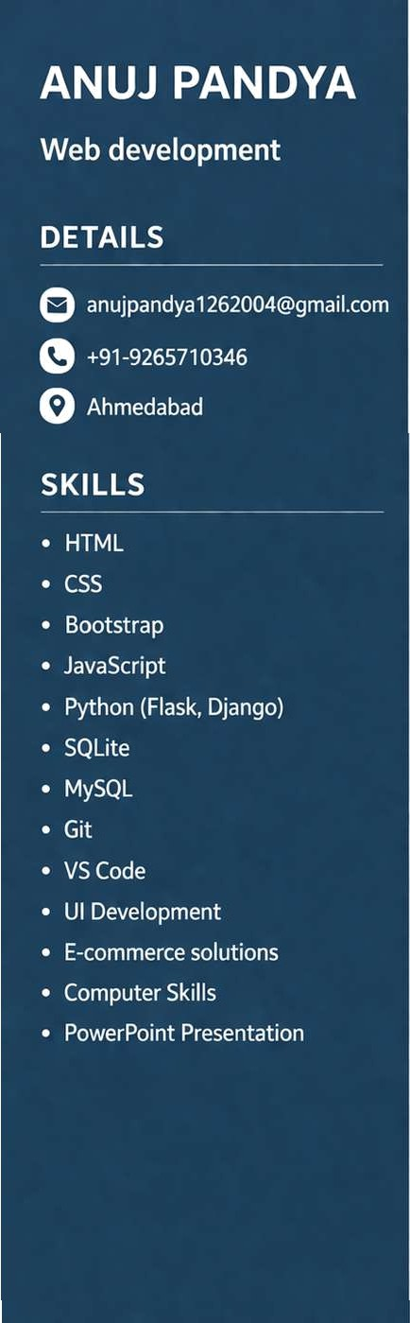
SUMMARY
Passionate Web Developer with strong knowledge of full-stack development using Python, Flask/Django, and modern frontend technologies. Skilled in building real-world applications with clean UI and scalable backend systems.

EXPERIENCE

Jan 2025 — May 2025
Intern

I Tech Brains, Ahmedabad
Completed internship working on ’Celebration and Design’ project using Django framework.

EDUCATION
2022 — 2025
B.Tech/B.E. in Computers
Silver Oak College of Engineering and Technology, Ahmedabad
B Tech in Computer Engineering
- Completed coursework with a CGPA of8.21/10
2019—2022
Diploma
M Polytechnic, Ahmedabad
Diploma in Computer Engineering
- Completed coursework with a CGPA of 7.28/10

PROJECTS
GROW PHARMA
E-commerce Store January 2022— March 2022 Designed a web-based platform to streamline pharmaceutical purchasing.
Built features for medicine browsing and inventory tracking. Ensured regulatory compliance and secure customer account management.

